PART I - TO BE COMPLETED BY PARENT

Student: ________________________________ D.O.B: __________ Teacher/Grade:_____________
Allergy to: ________________________________________________ Weight: ________________lbs.
Asthma: Yes (Higher risk for severe reaction) No

Note: Antihistamines and Inhalers are not to be depended upon to treat a severe reaction. USE EPINEPHRINE

PART II - TO BE COMPLETED BY LICENSED HEALTH CARE PROVIDER
Extremely reactive to the following allergens:_______________________________________________
Therefore:
⁯If checked, give epinephrine immediately if the allergen was LIKELY eaten, for ANY symptoms.
⁯ If checked, give epinephrine immediately if the allergen was DEFINITELY eaten, even if no symptoms are apparent.
- INJECT EPINEPHRINE IMMEDIATELY

- Call 911. Tell emergency dispatcher the person is having anaphylaxix and may need epinephrine when emergency respnders arrive.
- Consider giving additional medications following epinephrine:
- Antihistamine
- Inhaler (bronchodilator) if wheezing
- Lay the person flat, raise legs and keep warm. If breathing is difficult or they are vomiting, let them sit up or lie down on their side.
- Ifsymptoms do not improve, or symptoms return, more doses of epinephrine can be given about 5 minutes or more after the last dose.
- Alert emergency contacts.
- Transport patient to ER, even if symptoms resolve. Patient should remain in ER at least 4 hours because symptoms may return.

FOR ANY OF THE FOLLOWING: SEVERE SYMPTOMS

LUNG Short of Breath, wheeze, repetitive cough

HEART Pale, blue, faint, weak pulse, dizzy, confused

THROAT Tight, hoarse, trouble breathing or swallowing

MOUTH Significant swelling (tongue or lips)

SKIN Many hives over body, widespread redness

SKIN Hives, itchy rashes, swelling

GUT Repetitive vomiting, severe diarrhea

OTHER Feeling something bad is about to happen,
anxiety, confusion

OR A COMBINATION of symptoms from different body areas.

FOR MILD SYMPTOMS FROM MORE THAN ONE SYSTEM AREA, GIVE EPINEPHRINE.

. FOR MILD SYMPTOMS FROM A SINGLE SYSTEM AREA, FOLLOW BELOW DIRECTIONS

- GIVE ANTIHISTAMINE if ordered.
- Stay with student, alert emergency contact.
- Watch closely for changes. If symptoms worsen, give epinephrine.
MILD SYMPTOMS

NOSE Itchy or runny nose, sneezing

MOUTH Itchy mouth

SKIN A few hives around mouth/face mild itch

GUT Mild nausea/discomfort

MEDICATIONS/DOSES:

Epinephrine Brand or Generic: __________________________ Epinephrine Dose: 0.1 mg IM 0.15 mg IM 0.3 mg IM

Antihistamine Brand or Generic: _________________________ Antihistamine Dose: __________________________________

(Antihistamines should NOT be used as a first line of treatment during an anaphylaxis episode. It will treat itching ONLY-it will not halt vascular collapse or swelling!)

Other (e.g., Inhaler-bronchodilator if wheezing):_________________________________________________________________

It is my professional opinion that this student SHOULD/SHOULD NOT carry his/her epinephrine auto-injector.

___________________________/________________________________ _______________________ _______________
Licensed Health Care Provider Authorization (Print / Signature) Telephone Date

PART III - PARENT SIGNATURE REQUIRED

Student___________________________________ Date of Birth ______________Teacher/Grade_____________

Administration of an oral antihistamine should be considered only if the student’s airway is clear and there is minimal risk of choking.

MONITORING
Stay with student, Call 911 and then emergency contact. Tell 911 epinephrine was given, request an ambulance with epinephrine. Note time when epinephrine was administered. A second dose of epinephrine can be given about 5 minutes or more after the last dose.

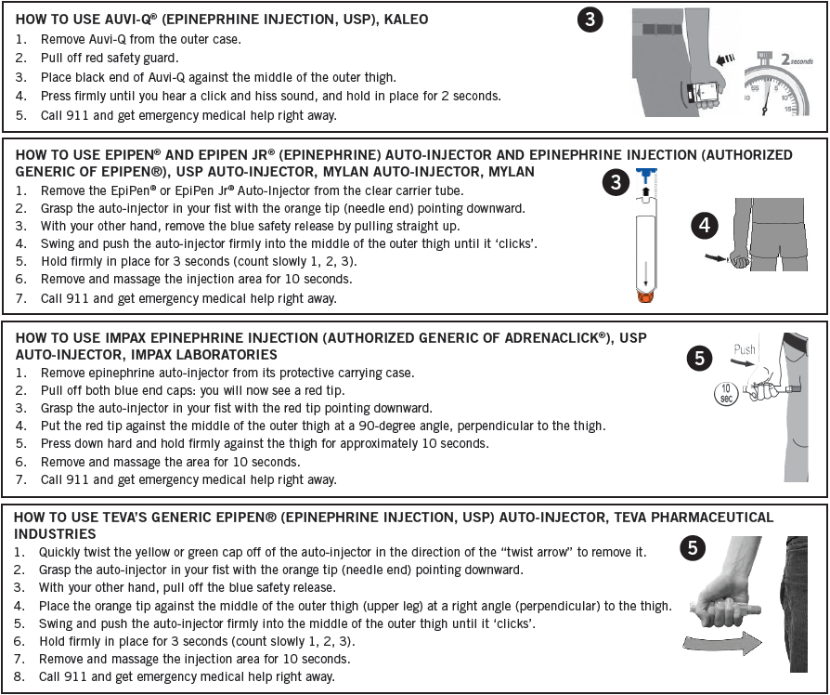
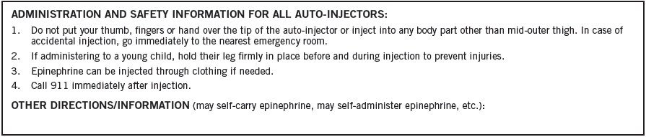

A food allergy response kit should contain at least two doses of epinephrine, other medications as noted by the student’s physician, and a copy of this action plan and treatment authorization. A kit must accompany the student if he/she is off school grounds (i.e., field trip).

Treat the person before calling emergency contacts. The first signs of a reaction can be mild, but symptoms can get worse quickly.

EMERGENCY CONTACTS:

Name/Relationship: ___________________________________________ Phone:__________________________
Name/Relationship: ___________________________________________ Phone:__________________________
Name/Relationship: ___________________________________________ Phone:__________________________

I hereby authorize for school personnel to take whatever action in their judgment may be necessary in providing emergency medical treatment consistent with this plan, including the administration of medication to my child. I understand the Virginia School Health Guidelines, Code of Virginia, 8.01-225 protects school staff members from liability arising from actions consistent with this plan.

_________________________________________________________ ______________________ ___________________
Parent / Guardian Authorization Signature Telephone Date

PARENT INFORMATION ABOUT MEDICATION PROCEDURES
- In no case may any health, school, or staff member administer any medication outside the framework of the procedures outlined here in the Office of Catholic Schools Policies and Guidelines and Virginia School Health Guidelines manual.
- Schools do NOT provide medications for student use. (However, High Schools may have a limited stock of Over the Counter (OTC) medications in their clinic. A parent/guardian may sign the OTC High School Medication Authorization Form and these medications can be given to your student should the need arise.)
- Medications should be taken at home whenever possible. The first dose of any new medication must be given at home to ensure the student does not have a negative reaction.
- Medication forms are required for each Prescription and OTC medication administered in school.
- All medication taken in school must have a parent/guardian signed authorization. Prescription medications, herbals and OTC medications taken for 4 or more consecutive days also require a licensed healthcare provider’s (LHCP) written order. No medication will be accepted by school personnel without the accompanying complete and appropriate medication authorization form.
- The parent or guardian must transport medications to and from school.
- Medication must be kept in the school health office, or other principal approved location, during the school day. All medication will be stored in a locked cabinet or refrigerator, within a locked area, accessible only to authorized personnel, unless the student has prior written approval to self-carry a medication (inhaler, Epi-pen). If the student self carries, it is advised that a backup medication be kept in the clinic.
- Parents/guardians are responsible for submitting a new medication authorization form to the school at the start of the school year and each time there is a change in the dosage or the time of medication administration.
- A Licensed Health Care Provider (LHCP) may use office stationery, prescription pad or other appropriate documentation in lieu of completing Part II. The following information written in lay language with no abbreviations must be included and attached to this medication administration form. Signed faxes are acceptable.
  - Student name
  - Date of Birth
  - Diagnosis
  - Signs or symptoms
  - Name of medication to be given in school
  - Exact dosage to be taken in school
  - Route of medication
  - Time and frequency to give medications, as well as exact time interval for additional dosages.
  - Sequence in which two or more medications are to be administered
  - Common side effects
  - Duration of medication order or effective start and end dates
  - LHCP’s name, signature and telephone number
  - Date of order
- All prescription medications, including physician’s samples, must be in their original containers and labeled by a LHCP or pharmacist. Medication must not exceed its expiration date.
- All Over the Counter (OTC) medication must be in the original, small, sealed container with the name of the medication and expiration date clearly visible. Parents/guardians must label the original container of the OTC with:
  - Name of student
  - Exact dosage to be taken in school
  - Frequency or time interval dosage is to be administered
- The student is to come to the clinic or a predetermined location at the prescribed time to receive medication. Parents must develop a plan with the student to ensure compliance. Medication will be given no more than one half hour before or after the prescribed time.
- Students are NOT permitted to self medicate. The school does not assume responsibility for medication taken independently by the student. Exceptions may be made on a case-by-case basis for students who demonstrate the capability to self-administer emergency life saving medications (e.g. inhaler, Epi-pen).
- Within one week after expiration of the effective date on the order, or on the last day of school, the parent or guardian must personally collect any unused portion of the medication. Medications not claimed within that period will be destroyed.

